Tax Policy Changes in the American States[1]*

Carlisle Rainey[2]§

Kevin Stout[3]†

Richard F. Winters[4]‡

Word Count: 8,362

**Abstract**

In spite of the attention paid by candidates and media to policy promises in campaign speeches and party platforms, prior work often finds little or no relationship between party control of political institutions and policy outcomes. We introduce a new data set containing enacted revenue changes in the 50 U.S. states by class of tax and use Random Forests—an ensemble of regression trees that can nonparametrically represent a wide random set of relationships—to predict these changes as a function political and economic variables. We find that states are highly responsive to budget imbalances and that unified Republican and Democratic state governments respond to these changes differently. States' tax policies also respond to changes in personal income. Further, shifts in the partisan composition of the legislature lead to changes in tax policy, especially corporate taxes.

# Introduction

The zero, weak negative, or weak positive relationship between measures of political party control and measures of policy change is one of the puzzling findings of analyses of American state politics (Caughey, Warshaw, and Xu 2016 has an excellent review). In spite of these results, political party control ought to have predictable consequences for public policy across the states and across time, especially in Democrats’ and Republicans’ response to budgetary difficulties, such as an unexpected fiscal imbalance. After all, Republican and Democratic politicians campaign differently—Republicans on the basis of lower taxes and Democrats on the basis of greater services. If these campaign promises predict policy at all, then plausible changes in public policies should occur under Democratic leadership and other changes under Republican leadership (Alt and Lowry 1994). For example, income taxes might decrease when Republicans are in power and Democrats might respond to budget shortfalls by increasing corporate and income taxes. In this paper, we focus on the 1987 to 2011 period in the American states and examine the effects of economic, partisan, and political variables on changes in several classes of taxes. We develop intuitions about when and how certain tax classes should change. Our empirical analysis is largely exploratory, and we identify several regularities in tax policy changes that demand further empirical and theoretical investigation.

Barrilleaux, Holbrook, and Langer (2002) note that a good portion of the literature on partisan control in the American states appears contradictory. On the one hand, some research adopts what we refer to as the naïve view (e.g., Winters 1976) that partisans have sincere preferences, and, once elected, seek to implement policies upon which they campaigned. Other research adopts a more strategic and Downsian view (Downs 1957a, 1957b) of politicians’ behavior, where “parties formulate policies in order to win elections, rather than win elections in order to formulate policies” (1957b, p. 28). As Barrilleaux and colleagues (2002) note, under some conditions partisan sincerity may well emerge, while under opposing conditions, the more strategic view likely dominates. They examined the effects of just-completed gubernatorial campaigns and argued that as incumbents’ margins of victory increase, governors are more likely to engage in sincere programmatic behavior. We proxy an institutional equivalent of this condition and argue that under *unified party control* we expect greater sincere behavior from the two parties—*more taxation and personal and corporate tax increases passed by Democrats and/or less taxation and/or more sales tax changes by Republicans*.

Our analysis also responds to three other issues in the partisan control-policy change literature. First, most analysts focus on quite broad understandings of policy and policy change. Many of the analyses employ highly aggregated measures of public policy. Most recently, Caughey, Warshaw, and Xu (2016) rely on a time series of the summation of 150 different public policies over the 1936 to 2014 period. Erikson, Wright and McIver (1989, 1993) employ a similar composite and highly aggregated measure of public policy liberalism in assessing the impacts of partisanship and ideology.[5] These global views of the policy process are attractive summations of what, on balance, governments do state-by-state, what we might term a state's public policy “mood.” However, we argue that *the* important focus of political science should be the explanation of changes in *particular*, deeply sanctioned public policies.[6] We can think of no set of policies where the authoritative allocations of indulgences and deprivations are more keenly and widely distributed than in the dollar-by-dollar changes in taxes actually altered by state actions. In contrast to the broad view of policy, we focus on *particular taxes* being changed by *particular amounts* at *particular moments* by *particular* partisans*.*

Secondly, even when analysts focus on dollar measures of tax policy in the states, they typically examine summary dollar measures.(Dennis, Moore and Somerville 2007; Dilger 1998; and Frederiksson, Wang and Warren 2013) which are a mix of changes in the economy, personal incomes, changes in consumption of items/services taxed, and possibly changes in statutory enactments in the taxes that a state adopts. The latter, of course, is the proper object of political scientists’ attention, and we focus on precisely that. Leigh (2008) examines income tax receipts, which again, are a compound of many different causal influences. Finally, two widely cited articles in economics and political science also use aggregate measures. Alt and Lowery (2000, 1050) examine “revenue change, …the annual change in constant-dollar (1982-1984), per capita state general revenues from 1952 through 1995,” and Poterba (1994) focuses, as well, on dollar levels of taxation, expenditures, and deficits—and usually measured after the fact of an administration. A better focus ought to be, we argue, on what specific policies politicians authoritatively change by force of law and not on the aggregates that are shaped by a myriad of factors. The existing levels, amounts, or changes in taxes collected are a compound of many factors, where political choices are only one of many. In our analysis, we focus on the discrete tax choices that politicians make in promoting (governors) or enacting (legislatures).

Finally, when analysts do focus on changes in specific taxes, they typically examine the *changes in rates of the taxes* (Mikesell, 1978, for example). But taxes can be changed via routes other than rate changes. For example, conditions or coverages of the tax category might change. In 2013, Governor Peter Shumlin of Vermont proposed exempting cloud computing from sales tax, reducing revenue by about $1.5 million; and Governor John Kasich of Ohio proposed greatly expanding the sales tax base, increasing revenue by about $1.9 billion. None of these cases involved a change in the tax *rate*. Non-rate-changes appear, in fact, to be the modal type of change and the NASBO data that we employ captures the dollar amount of all changes in taxes, in the totals and in specific classes of taxes, irrespective of the modalities of the changes.[7] Mikesell (1978), replicated by Nelson (2000), and analyzed by Case (1994), looks at published sources which document changes in existing rates usually of broad-based taxes such as the income and general sales and typically derived from the *Book of the States.* However, the simple changes in the tax rates do not always capture changes in the amount of dollars collected. An example: NASBO’s data on state-by-state, change-by-change details are unpacked in Table A-3 of—as an example—the 2011 publication (p. 76), and, in that year, there were nineteen discrete statutory changes in sales taxes across the states, but only four of these changes might plausibly be caught up as a change of rates via the *Book of the States*. Our data sweeps up and aggregates all changes in taxes by the class of tax, not just changes in the tax rate. Changes in rates are important, but the dollar-change in taxes remains the more politically-relevant variable. In point of fact, it may be the case that in any electoral timing of tax changes by politicians, elected political actors—executives and legislators—prefer *non-rate electoral year changes in tax laws* because these more subtle changes are less likely to gain public recognition (and eventual voter opprobrium) and thus more easily agreed-upon. Mikesell's (1978) well-known linkage of gubernatorial tax-rate-change-aversion and the timing of the election year might be better thought of an aversion to changes in the tax rates in the year before the election, where rate changes will more likely catch the public eye and provide campaign fodder for an opponent.[8]

# The NASBO Data

Annually since 1986, the National Association of State Budget Officers (NASBO) publishes a record of the tax policy change recommendations of the governors of the states in their budget and revenue messages to the states’ legislators. In a like and later table, they publish the legislated changes in taxes, a state-by-state assessment of the enacted statutory changes in rates, coverages, or extensions for eight classes of revenues, taxes, charges, and fees for that legislative year and the sum of all such legislated assessments. Two traits make these data particularly interesting. As noted above, the revenue changes are arrayed into politically relevant categories (sales, income, corporate, cigarette and tobacco, fuel, alcohol taxes, other taxes, and fees) and they are presented in terms of the nominal amounts of *new* dollars expected, given the statutory changes. We have collected these data into a useable table and Figure 1 plots the total *enacted changes* for each year. There is a lot of variation to explain. Some states, such as Ohio and Florida, tend to change taxes quite often, while other states, such as Vermont and New Hampshire, change taxes less often.

[Figure 1 here]

Put simply, this new data set of tax and revenue changes represents (1) the beginning-of-the-budget-process set of gubernatorial requests and (2) the final, agreed-upon legislative actions for each year’s regular and special legislative sessions on new revenue dollars put into place. It is the state-by-state chief executives' suggestions, and then legislative actions, and final gubernatorial approvals in extracting a greater, or perhaps smaller, share of wealth from their citizens so as to finance public goods. Among the important questions raised about tax policy changes in these data, three initial ones are:

1. Under what political and economic conditions do states change particular tax policies?
2. Under what political and economic conditions do governors propose changes to particular tax policies?
3. What is the impact of the governor's proposal on the actual changes in particular tax policies?

As part of our larger project, we are examining each of these three questions in detail. In the paper, though, we examine the first question—the political and economic conditions under which states change particular tax policies.

Figure 2 plots the direction (i.e., increase, no change, decrease) for each of the eight tax class and the total changes in the 49 states across the 25 year period from 1987 to 2011. In sum, this presents 9,800 possible revenue changes—49 states (we exclude Nebraska and states with independent governors, e.g. Jesse Ventura (MN) from our analysis) for 25 years in eight tax classes. The status quo prevailed in 71% (7,706) of these state-year-class observations, an increase occurred in 16% (1,780), and a decrease occurred in 12% (1,350).

[Figure 2 here]

But the distribution of direction of changes varies across the categories. Figure 3 also plots the distribution of the direction of the changes for each tax class. The total enacted revenue changed in 71% of the observations, with about 1.2 time more increases than decreases. Sales taxes were 1.3 times more likely to be decreased than increased, while income taxes were 1.7 times more likely to be decreased.[9] Corporate taxes were slightly more likely to be decreased and other taxes were slightly more likely to be increase. However, states were much more likely to increase rather than decrease the remaining tax classes: cigarette and tobacco taxes were 31.2 times more likely to be increased;[10] fuel taxes were 5.4 times more likely to be increased; alcohol taxes were 3.1 times more likely to be increased; and fees were 8.8 times more likely to be increased.

We explore the partisan determinants of changing taxes and model these factors in straightforward fashion. One of the earliest and most enduring findings of policy analysis in the American states is the importance of social and economic factors in accounting for policy change (Dawson and Robinson 1963; Hofferbert 1966; Barrilleaux, Holbrook and Langer 2002). The simplest way to conceive these factors are the social factors that generate the *demand* for public goods, and the economic factors that *supply* the wherewithal to satisfy the demands for such goods. In our simple model, these demand (1 and 2) and supply (3 and 4) factors are, respectively, the (1) *population of the state* and the (2) *change in population* (Klarner 2013a)*;* and *(3) total personal income* in the state and (4) *change in that income* (Klarner 2013a). Further, we propose that there is a long-lasting, latent trait of the taste for public goods that will vary across states and across time. We capture this trait by a time series of (5) *statewide citizen ideology* (Berry et al. 1998).

Every year, traditionally at the beginning of the legislative session, the states’ governors deliver their state of the state addresses that contain spending and taxing recommendations as well as (6) *the budget balance estimate of a surplus or deficit.* In times of surplus, spending priorities may well outweigh the interest of lowering taxes, but nevertheless, may spur the interest of “tax-cutters” among legislators. In our understanding of unified governments, the “spenders” likely dominate in Democratic administrations, while the “cutters” likely triumph in the controlling Republican caucuses. Recognizing the time-series/cross-sectional nature of our data set, we also include (7*) the prior year’s level of state revenues* as a control variable.

Our primary focus is assessing the impact of partisan control on tax changes, and for these, we choose the simplest of all partisan control variables: (8) *the partisanship of the governor* (Klarner 2013a); (9) the *Democratic share of the Senate seats* (Klarner 2013b)*; (10) the Democratic share of the House seats* (Klarner 2013b)*; and (11), (12), and (13), the change in these variables' shares year-to year.*

# The Empirical Approach

Rather than set up a structural statistical model based on strong and perhaps unreasonable assumptions about the conditional distribution of the outcome (i.e., normality) and the relationship among the explanatory variables and the conditional mean of the outcome (i.e., linearity), we adopt a more flexible approach using Random Forests (Breiman 2001, Jones and Linder 2015).

We expect highly nonlinear and interactive relationships with these data such as a kink in the relationship between the estimated imbalance and the expected changes in tax policy. We also expect many interactions, such as Democratic and Republican politicians dealing with an estimated imbalance in different ways. Standard statistical methods require pre-specifying a precise functional form that can capture these interactions and nonlinearity. However, rather than *prespecify* this functional form, our approach is to *estimate* it with a Random Forest. We expect a complex relationship between our explanatory variables and changes in tax policy. Random Forests allow us to capture that complexity.

This approach has two distinct advantages:

1. First, using a highly flexible approach based on theoretical intuitions rather than a precise theory, we are free to *explore* the relationships in our rich data and *discover* substantively interesting and relevant regularities. We hope our work can then motivate scholars to investigate these regularities more carefully using detailed case-studies, formal models, and clever research designs. We are not interested in testing specific hypotheses using a specific statistical model implied by a precise theory, but in exploring the data using our theoretical intuition as a guide. In light of these goals, the flexibility of Random Forests offers an enormous benefit.
2. Second, these data follow a highly unusual distribution. Figure 3 shows a scatterplot of the enacted revenue changes and the estimated imbalance. Notice unusual distributions of the outcome variables. There are an unusually large number of exact zeros. Also, there are several highly deviant cases. This suggests that a standard parametric model (e.g., normal-linear model or a linear random-effects model) might offer misleading inferences. Random Forests make no assumptions about the distribution of the outcome variable, so they offer an especially useful tool for these data.

[Figure 3 here]

To aid interpretation, we standardize each of the enacted changes in revenue (in dollars) by dividing it by the previous year’s total revenues. This makes the changes across large and small states comparable. Second, we scale this quotient by dividing by its standard deviation. This makes the changes comparable across tax classes.[11]

## Explanatory Variables

In our analysis, we include a range of explanatory variables intended to capture the political and economic context suggested by the previous literature. Note that all dollar values in this paper are in nominal values, normalized to have a reasonable scale (e.g., in billions of dollars). The variables we discuss above and include in the model are:

Political *supply* variables for taxation:

1. total statewide personal income - greater taxable base

2. percentage change in the total statewide personal income - increases in the taxable base

Political *demand* for tax-supported services:

3. total statewide population - greater public need

4. percentage change in total statewide population - change in public need

5. statewide citizen ideology - taste for public goods

Fiscal/economic controls:

6. gubernatorial January budget balance estimate - best estimate of resources

7. total state revenues in the previous fiscal year - existing resource base

Political/partisan variables

8. the governor’s partisanship - expected direction of the tax change

9. whether there was a change in the governor’s partisanship from the last year to the current year - change from prior year's supply, need, and taste

10. the Democrat’s two-party seat-share in the state house - expected direction of the tax change

11. the change in the Democrat’s two-party seat-share in the state house - change in expected direction of the tax change

12. the Democrat’s two-party seat-share in the state senate - expected direction of the tax change

13. the change in the Democrat’s two-party seat-share in the state senate= change in expected direction of the tax change

## Random Forests

Random Forests are simply a large collection of decision trees—conditional inference trees (Hothorn, Hornik, and Zeileis 2006) in our case—used to predict the enacted revenue change.[12] This approach allows a variety of interactions and non-linearities to enter the model *without prespecification* (Biau, Devroye, and Lugosi 2008) and offers an effect methods to assess variable importance (Strobl et al. 2007). Intuitively, random forests are simply a collection of decision trees that predict enacted revenue changes for each state-year. The forest contains many trees and each tree is built as follows:

1. Select 63% of the cases from the data set without replacement to train the model. Set the remaining 37% of cases aside as a test set (for use when calculating variable importance, for example). Use training cases to build a decision tree to predict enacted revenue changes.
2. Select four predictors at random from the set of 13 predictors mentioned above. From these four predictors, choose the variable and, if continuous, the split that best classifies the observations in the training data. Continue drawing four predictors at random and optimally partitioning the data using these predictors until the splits are no longer statistically significant.

There are two features of each tree that make it random. First, each tree is fit to a random 63% of the data. Second, at each node of the tree, only a subset of the explanatory variables are considered for the split. We consider four explanatory variables at each split. When repeated many times, the resulting trees can be combined into a forest. We used 2,500 trees in our forests. Predictions for a particular scenario are calculated by averaging across the predictions from each tree. We use the party package in R (Hothorn et al. 2006, Strobl et al. 2007, and Strobl et al. 2008) to build our forests.

## Out-of-Sample Comparison to Least Squares

To further justify our approach, we randomly split the data into categories. We randomly placed 70% of the data into a training set and 30% of the data into a test set. We use the training set to (1) build a Random Forest and (2) estimate a least squares regression. We then use these models to predict the observations in the training set (i.e., in-sample prediction) and the test set (i.e., out-of-sample predictions). The results illustrate the inadequacy of the normal-linear model for these data. Figure 4 compares the predictions for the training and test sets using both a Random Forest and least squares. The Random Forest predictions map noticeably more closely to the actual values than the least squares predictions. This pattern holds in both the training and test sets. Most importantly, the Random Forest predicts better *out-of-sample* than least squares fits *in-sample*.

[Figure 4 here]

To quantify the differences in explanatory power between the two models, we computed the mean squared error of the predictions in the test and training sets. Figure 5 shows the results. In both the training and test sets, the Random Forest reduces the mean squared error by about 25% compared to least squares. This evidence suggests non-linearity and/or interactions that least squares cannot capture, at least without a strong theory allowing the researcher to pre-specify particular forms of each into the model.

[Figure 5 here]

# Results

## What Variables Matter Most?

The first question we address is variable importance. Of the variables we consider, which are most important in predicting enacted revenue changes? We quantity “importance” in a specific way. If we permuted (i.e., randomly switched values) of an explanatory variable and used those permuted values to predict the outcome, how much worse would the predictions be? In particular, we calculate the difference between the mean squared error (i.e., predictive power) of the model on the test set (i.e., the “out-of-bag” sample—the 27% of data set aside as a test set when building each tree) using the actual and permuted explanatory variables for each tree. We then average these differences in mean squared error across the forest to obtain an overall measure of importance. Note that more positive values indicate greater importance and negative values can occur by chance for unimportant variables. Note that this measure of importance reveals nothing about the *direction* of an effect, simply its importance as a predictor of changes in tax classes.

Figure 6 shows the importance of each explanatory variable. For the total taxes, the most important variable is the estimated imbalance in the budget. This is intuitive, since states should respond to budget surpluses and shortfalls with changes in tax policy. (Note though, that the measures of variable importance do not indicate the *direction* of the relationship between the explanatory variable and the outcome.) Perhaps surprisingly, given the literature suggesting that partisanship does *not* have a large effect on, we find that the Democrats’ share of the state house and senate are among the most important predictors in our model. While Alt and Lowery (2000) “find *limited* but explicable party differences in state-level taxing and spending” (p. 811). Caughey, Warshaw, and Xu (2015) find that “legislative and gubernatorial elections have small, but statistically significant impact on policy outcomes” (p. 30). While the results suggest that the party of the governor is relatively less important, these results suggest that party control might matter more than previously thought. However, note that the variable importance measure does not indicate the nature of the relationship between partisan control and the tax policy changes. It could be, for example, that partisanship matters because it conditions the effect of other variables (i.e., interaction), not because it has a large effect on its own.

[Figure 6 here]

Other relatively good predictors of total enacted changes in revenues are the percent change in personal income, taxes collected in the previous year, and the change in the Democrats’ share of the state senate. Predictors that perform relatively less well include the governor’s party, the change in the Democrats’ share of the state house, the personal income, the percent change in the population, the population, the citizen ideology, and whether there was a change in the governor’s party.

The pattern of importance for sales taxes is quite different, and no variable we consider seems to exert much explanatory power. However, the pattern for income taxes closely mirrors the patterns for the total taxes.

## Estimated Imbalance

We now examine the relationship between the explanatory variables and the predicted changes in tax policy. However, while interpreting a single tree is straightforward, interpreting an entire forest of 2,500 trees is difficult. Jones and Linder (2015) recommend partial dependence plots, in which the researcher plots the prediction from the forest as the key explanatory variable varies from a high value to a low value, averaging across the other variables combinations of variables that occur in the data set. This is our basic approach, but we also include the predicted values for each combination of variables in the data set. Thus, for each value of the explanatory variable, we have many predictions—one prediction for each state-year-class. This additional information reveals the subtle nonlinearities and interactions that might go into the mean. In the plots below, the mean prediction for each value of the relevant explanatory variable is indicated by the heavy black line. The predictions for each observed combination of the other explanatory variables is indicated by the light line and shaded by the citizen ideology for that observation. Blue lines indicate liberal states, yellow lines indicate moderate states, and red lines indicate conservative states.

Figure 7 shows the predicted outcome for each state-year-class if we varied the estimated imbalance from the lowest observed value in the data set to the highest. These results point to an interesting, intuitive, and encouraging result. States respond to budget imbalances by changing tax policy. Conservative states are less likely to decrease taxes when facing a budget shortfall and more likely to decrease taxes when facing a budget surplus. Liberal states are always predicted to increase taxes, but even more so when facing a budget shortfall. Further, these effects are quite large. Recall that the enacted changes are standardized to have a standard deviation of one in each category. An average decrease of about one-half of a standard deviation is quite a large effect. Further, the effect of a budget imbalance is found across most tax classes and is particularly large for sales taxes, income taxes, and corporate income taxes—exactly where we would expect states to look for extra revenue.

[Figure 7 here]

**Observation 1**: Estimated imbalances in the budget have a large effect on a state’s predicted tax policy changes. On average, states facing a budget shortfall increase taxes substantially. On average, states facing a budget surplus increase taxes only slightly. A similar pattern emerges for most tax class, but most prominently for sales, income, and corporate taxes.

We investigate this further by plotting the predicted changes by the partisan control of each institution. Figure 8 groups the cases by control of the house and senate in the columns and rows, respectively, with the color indicating the partisanship of the governor. Of particular interest here are the differences in the responses of a unified Democratic state government and a unified Republican state government. The predictions for a unified Democratic state government are given by the blue line in the upper-left panel of Figure 8. The predictions for a unified Republican government is given by the red line in the lower-right panel. Notice that when facing a budget shortfall, the model predicts that Democratic governments respond with about a 0.9 standard deviation increase in the total taxes. When facing a surplus, the model still predicts that Democratic governments will respond with an increase, but smaller—about 0.2 standard deviations.

[Figure 8 here]

On the other hand, the model predicts that unified Republicans will respond to a shortfall with about a 0.2 standard deviation increase in total taxes and respond to a surplus with about a 0.1 standard deviation *decrease* in total taxes. That is, the model predicts that Democratic governments will increase taxes, regardless of the direction of the imbalance, but the direction of the imbalance has a large effect on the magnitude of increase. The model predicts that Republicans, on the other hand, will increase taxes slightly when facing a shortfall and decrease taxes slightly when facing a surplus. Figures 9, 10, and 11 reproduce these figures for the sales, income, and corporate taxes. They show that much of the difference in overall response is due to differential action on income taxes—little difference emerges between the parties in adjustment of sales and corporate taxes in response to imbalances.

Figures 9, 10, and 11 here]

**Observation 2**: Unified Democratic and unified Republican governments respond to budget imbalances differently. On average, unified Democratic governments increase taxes overall regardless of whether they face a shortfall or surplus, but increases tax much more when facing a shortfall. Unified Republican governments, on the other hand, increase taxes slightly when facing a shortfall and decrease taxes slightly when facing a surplus, on average. Most of these differences are due to differential changes to income taxes. Unified Democratic and Republican governments tend to change the sales and corporate taxes similarly in response to budget imbalances.

## Personal Income

A second important variable in the random forest is the percent change in personal income. The pattern here is intuitive as well. Figure 12 shows that, on average, states that see shrinking personal income increase taxes overall and much of this increase comes from the income tax. As income shrinks, states need to increase taxes to raise additional revenue. The relationship between personal income and sales and corporate taxes, is weak, as we might expect. Interestingly, states with large decreases in personal income are those most likely to raise fees.

[Figure 12 here]

**Observation 3**: On average, states with shrinking personal income increase income taxes.

**Observation 4**: On average, states with shrinking personal income substantially increase fees.

## Changes in Partisan Control

While some studies suggest little to no effect of government control on policy (e.g., Hofferbert 1966, Winters 1976, Hanson 1984, Plotnick and Winters 1985, Alt and Lowry 2000), we find a substantial effect of changes in the partisan composition of the legislature on changes in tax policy. Figures 13 and 14 show the predicted changes in tax policy as the change in the Democrats’ share of the state house and state senate varies, respectively.

[Figures 13 and 14 here]

Changes in Democrat’s share of the state house has a relatively weaker relationship with tax changes. The difference in predictions for a ten percentage point loss in seat share compared to a ten percentage point gain is about 0.2 standard deviations for total taxes. The predictions change little for income taxes. The relationship is stronger for sales taxes and corporate taxes. For sales taxes, the model predicts a difference of about 0.3 between states in which Democrats suffered a 15 percentage point loss and states in which Democrats managed a 10 percent gain. This runs counter to the conventional wisdom that Republicans should prefer sales taxes. For corporate taxes, the model predicts a difference of about 0.3 standard deviations when Democrat’s increase their seat share by ten percentage points or more compared to losing seats. The model predictions change little for the remaining taxes.

The model predictions vary much more strongly with changes in the Democrat’s share of the state senate. For example, moving from a small loss to a ten percentage point gain suggests about a 0.4 standard deviation increase in taxes overall. A similar change suggests about a 0.2 standard deviation increase in the sales tax. As before, this is somewhat unexpected. There is not a large change in the prediction for income taxes, though the model does predict a small decrease in income taxes when Democrats suffer a major loss of 18 percentage points or more. The prediction for changes in corporate taxes depends *heavily* on change in the Democrats’ share of the senate—even more so than the Democrats share of the house. When Democrats gain 10 percentage points or more in the senate, the model predicts about a 0.8 standard deviation increase in corporate taxes. This is an enormous difference. We also see a similar, though not quite as strong, pattern for cigarette and tobacco taxes—when Democrats’ make large gains in the state senate, the model predicts a 0.5 standard deviation increase in these taxes. An similar, but even weaker pattern emerges for other taxes. The predictions for the remaining tax classes do not depend heavily on the change in Democrat’s vote share.

As Figure 14 suggests, the relationship between the party of the governor and the enacted revenue changes is much weaker. This is consistent with Kousser’s (2002) finding that control of the legislature is “important” but the party of the governor “appears irrelevant” (p. 667).

[Figure 14 here]

**Observation 5**: On average, Democratic gains in the state legislature are associated with a moderate increase in the sales tax and a large increase in the corporate income tax, but little to no relationship with the income taxes.

# Conclusion

If politics is, as Lasswell claims, as “who gets what, when, and how” (1936), then fundamental to the (re)distribution of “the whats,”—governmental goods and services—is taxation -- obtaining governmental wherewithal. Yet political scientists have a relatively poor understanding of how politics and economics affect taxation, especially their *interaction*. Indeed, most studies find little to no relationships between public policy, including taxation, and partisan control. This presents a fundamental problem for the functioning of a democracy. Parties compete and win or lose based on a series of policy proposals put forth to voters. The usual assumption is that parties will, at least to some extent, govern based on these platforms. The 1950 APSA report “Toward a More Responsible Two-Party System observes that

“An effective party system requires, first, that the parties are able to bring forth programs to which they committed themselves and, second, that the parties possess sufficient internal cohesion to carry out these programs” (p. 305)

If parties, through institutional constraints or some other reason, are unable to follow through on their campaign promises and party platforms, this suggests that the people have little control over the government.

While previous results find little to no impact of party control on most measures of policy outcomes, we find that party matters. Perhaps not for all policy areas, but for the vitally important ones of whether, how, and by how much states finance the distributions of public goods, party seems to matter. We find that a Democratic gain in the legislature predicts greater taxes, on average, especially corporate taxes. Most importantly, we find that state governments respond to the changing economic climate and the these changes are consistent with the general party positions. When facing a budget surplus, Democrats enact small tax increases on average, and Republicans enact small tax cuts on average. When facing a budget shortfall, Democrats enact large tax increases on average, and Republicans enact small tax increases on average. This suggests two basic points that paint quite an optimistic view of state government. First, parties are able to change policy. Second, parties are able to present platforms and carry out those platforms in office.

A greater understanding of taxation policy and the resources of government are important pieces in understanding public policy. The relationship between election outcomes and policy is a crucial link for democracy. We have established clear tax policy differences between the parties and offered guidance for future research. Although our results point to the importance of legislative partisanship over gubernatorial partisanship, there is an opportunity to better examine the interplay between the two in the taxation process. The results also serve as a starting point for further research linking state taxation changes with political, fiscal, and economic factors. The ability for parties to influence tax policy should provide encouragement for further theoretical and empirical research regarding public policy and taxation at the state level.

# References

Alt, James and Robert Lowry. 2000. “A Dynamic Model of State Budget Outcomes under Divided Partisan Government.” *The Journal of Politics*, 62: 1035-1069.

Alt, James and Robert Lowry 1994. “[Divided Government, Fiscal Institutions, and Budget Deficits: Evidence from the States](http://www.jstor.org/stable/10.2307/2082709?Search=yes&resultItemClick=true&&searchUri=%2Faction%2FdoAdvancedSearch%3Fq1%3D%26amp%3Bdc.politicalscience-discipline%3Don%26amp%3Bf4%3Dall%26amp%3Bf5%3Dall%26amp%3Bwc%3Don%26amp%3Bgroup%3Dnone%26amp%3Bar%3Don%26amp%3Bf6%3Dall%26amp%3Bq2%3D%26amp%3Bq6%3D%26amp%3Bla%3D%26amp%3Bsd%3D%26amp%3Bpt%3D%26amp%3Bf1%3Dall%26amp%3Bq3%3D%26amp%3Bf3%3Dall%26amp%3Bc2%3DAND%26amp%3Bq4%3D%26amp%3Bf2%3Dall%26amp%3Bacc%3Don%26amp%3Bq0%3DRobert%2BLowry%26amp%3Bed%3D%26amp%3Bc3%3DAND%26amp%3Bc5%3DAND%26amp%3Bf0%3Dau%26amp%3Bq5%3D%26amp%3Bc6%3DAND%26amp%3Bisbn%3D%26amp%3Bc1%3DAND%26amp%3Bc4%3DAND).” "*The American Political Science Review* 88: 811-828.

[American Political Science Association. Committee on Political Parties.](http://libcat.dartmouth.edu/search~S1?/aAmerican+Political+Science+Association.+Committee+on+Political+Parties./aamerican+political+science+association+committee+on+political+parties/-3,-1,0,B/browse) 1950. “Toward a More Responsible Two-Party System: A Report....” New York : Rinehart.

Barrilleaux, Charles, and Michael Berkman. 2003. “Do Governors Matter? Budgeting Rules and the Politics of State Policymaking.” *Political Research Quarterly* 56: 409-417.

Barrilleaux, Charles, Thomas Holbrook, and Laura Langer. 2002. “Electoral Competition, Legislative Balance, and American State Welfare Policy.” *American Journal of Political Science* 46: 415-427.

Baumol, W.J. and W. G. Bowen. 1965. “On the Performing Arts: The Anatomy of Their Economic Problems.” *The American Economic Review* 55: 495-502.

Beamer, Glenn. 1999. *Creative Politics: Taxes and Public Goods in a Federal System*, Ann Arbor: The University of Michigan Press.

Biau, Gérard, Luc Devroye, and Gábor Lugosi. 2008. “Consistency of Random Forests and Other Averaging Classifiers.” *The Journal of Machine Learning Research* 9: 2015-2033.

Birnbaum, Jeffrey and Alan Murray. 1987. *Showdown at Gucci Gulch.* New York : Random House.

*Book of the States*. Lexington, Ky. Council of State Governments, various biennial volumes.

Breiman, Leo. 2001. “Random Forests.” *Machine Learning* 45(1): 5-32.

Campbell, Angus, Philip Converse, Warren Miller, and Donald Stokes. 1960. *The American Voter,* New York: John Wiley and Sons.

Case, Anne. 1994. “Taxes and the Electoral Cycle: How Sensitive Are Governors to Coming Elections?” *Business Review*, Federal Reserve Bank of Philadelphia.17-26.

Caughey, Devin, Christopher Warshaw, Yiqing Xu. 2015. “The Policy Effects of the Partisan Composition of State Government.” Unpublished ms. MIT. Dated February 5, 2015.

Dawson, Richard E. and James A. Robinson. 1963. “Inter-Party Competition, Economic Variables, and Welfare Policies in the American States.” *The Journal of Politics* 25(2): 265-289

Dennis, Christopher, William S. Moore, and Tracey Somerville. 2007. “The Impact of Political Parties on the Distribution of State and Local Tax Burdens.” *The Social Science Journal* 44: 339-347.

Dilger, Robert Jay. 1998. “Does Politics Matter? Partisanship’s Impact on State Spending and Taxes, 1985-95.” *State and Local Government Review* 30(2):139-144.

Dominguez, Nicholas, Tyler E. Frisbee, and Richard F. Winters. 2009. “...Divided, We Fail: The Impact of Primary Divisiveness on Gubernatorial Elections.” A paper presented at the 2009 Conference on State Politics and Policy at Temple University.

Downs, Anthony. 1957. [*An Economic Theory Of Democracy*](http://francis.williams.edu/search~S0?/adowns%2C+anthony/adowns+anthony/1%2C1%2C22%2CB/frameset&FF=adowns+anthony&3%2C%2C22/indexsort=-)*.* New York. Harper.

Erikson, Robert S. 1971. “The Relationship between Party Control and Civil Rights Legislation in the American States.” *The Western Political Quarterly* 24(1): 178-182.

Erikson, Robert S., Gerald C. Wright and John P. McIver. “Political Parties, Public Opinion and State Policy in the United States.” *American Political Science Review*, 83: 729-50.

Erikson, Robert S., Gerald C. Wright, and John P. McIver. 1993. *Statehouse Democracy: Public Opinion, and Policy in the American States*. Cambridge University Press.

Franzese, Robert. 2008. “Political-Economic Cycles.” In Barry R. Weingast and Donald Wittman (eds.), *The Oxford Handbook of Political Economy*, Oxford, UK, pp. 545 and 559-560.

Fredriksson, Per G., Le Wang, and Patrick L. Warren. 2013. “Party Politics, Governors, and Economic Policy.” *Southern Economic Journal* 80: 106-126.

Fry, Brian and Richard F. Winters. 1970. “The Politics of Redistribution.” *American Political Science Review,* 64: 508-522.

Goetz, C.J. 1977. “Fiscal Illusion in State and Local Finance.” In Borcherding, Thomas (ed.) *Budgets and Bureaucrats: The Sources of Government Growth.* Durham, NC: Duke University Press; as quoted in Mikesell, p. 99.

Hofferbert, Richard. 1966. “The Relation between Public Policy and Some Structural and Environmental Variables in the American States.” *The American Political Science Review* 60(1): 73-82.

Hothorn, Torsten, Kurt Hornik, and Achim Zeileis. 2006. “Unbiased Recursive Partitioning: A Conditional Inference Framework.” *Journal of Computational and Graphical Statistics* 15(3): 651-674.

Jones, Zachary M. and Fridolin Linder. 2015. “Exploratory Data Analysis Using Random Forests.” Working Paper. Available at <http://zmjones.com/static/papers/rfss_manuscript.pdf>.

Klarner, Carl. 2013a. “Governors Dataset.” <http://hdl.handle.net/1902.1/20408>. Harvard Dataverse. V1.

Klarner, Carl. 2013b. “State Partisan Balance Data, 1937 – 2011.” <http://hdl.handle.net/1902.1/20403>. Harvard Dataverse. V1.

Kone, Susan and Richard F. Winters. 1993. “Taxes and Voting: Electoral Retribution in the American States.” *The Journal of Politics* 55: 22-40.

Lasswell, Haorld. 1936. *Politics; Who Gets What, Whem, and How.* New York, McGraw Hill.

Leigh, Andrew. 2008. “Estimating the Impact of Gubernatorial Partisanship on Policy Settings and Economic Outcomes: A Regression Discontinuity Approach.” *European Journal of Political Economy* 24: 256-268.

Mikesell, John. 1978. "Election Periods and State Tax Policy Cycles," *Public Choice* 33: 99-106.

Montegomery, Jacob M. and Santiago Olivella. 2016. “Tree-Based Models for Political Science Data.” Forthcoming in the *American Journal of Political Science*. Copy at http://pages.wustl.edu/montgomery/trees.

National Association of State Budget Officers. *The Fiscal Survey of the States,* spring and fall issues., multiple years, National Governors Association, National Association of State Budget Officers, Washington, D.C.

Nelson, Michael. 2000. “Electoral Cycles and the Politics of State Tax Policy.” *Public Finance Review* 28: 540-560.

Niemi, Richard, Harold Stanley, and Ronald J Vogel. 1995. “State Economies and State Taxes: Do Voters Hold Governors Accountable?” *American Journal of Political Science* 39(4): 936-957.

Olson, Mancur. 1973. “Evaluating Performance in the Public Sector.” *The Measurement of Economic and Social Performance.* Milton Moss, (ed.).New York, National Bureau of Economic Research; distributed by Columbia University Press.

Plotnick, Robert and Richard Winters. 1990. “Party, Political Liberalism, and Redistribution . . .” *American Politics Research* 18: 430-458.

Poterba, James M. 1994. “States Responses to Fiscal Crises: The Effects of Budgetary Institutions and Politics.” *Journal of Political Economy*. 102: 799-821.

Rainey, Carlisle, Kevin Stout, and Richard Winters. 2015. “The Effects of Party Control, Electoral Cycles and Institutional Design on Tax Policy Changes.” A paper presented at 2015 meeting of the Midwestern Political Science Association, Chicago, IL.

Rainey, Carlisle, Kevin Stout, and Richard Winters. 2016. “Electoral Cycles and Tax Policy Change.” A paper presented at 2016 meeting of the Midwestern Political Science Association, Chicago, IL.

Reed, W. Robert. 2006. “Democrats, Republicans, and Taxes: Evidence that Political Parties Matter.” *Journal of Public Economics* 90: 725-750.

Stigler, George J. 1971. “The Theory of Economic Regulation.” *The Bell Journal Economics and Management Science* 2: pp. 3-21.

Strobl, Carolin, Anne-Laure Boulesteix, Achim Zeileis, and Torsten Hothorn. 2007. “Bias in Random Forest Variable Importance Measures: Illustrations, Sources and a Solution.” *BMC Bioinformatics* 8(25).

Strobl, Carolin, Anne-Laure Boulesteix, Thomas Kneib, Thomas Augustin, and Achim Zeileis. 2008. “Conditional Variable Importance for Random Forests.” *BMC Bioinformatics* 9(307).

Winters, Richard. 1976. “Party control and policy change.” *American Journal of Political Science* 20: 597-636.

Wright, Gerald C., Robert S. Erikson and John P. McIver. 1987. “Public Opinion and Policy Liberalism in the American States.” *American Journal of Political Science* 31: 980-1001.

Wright. Gerald, Leroy Reiselbach and Lawrence Dodd, (eds). 1986. *Congress and Policy Change*. New York, Agathon Press.

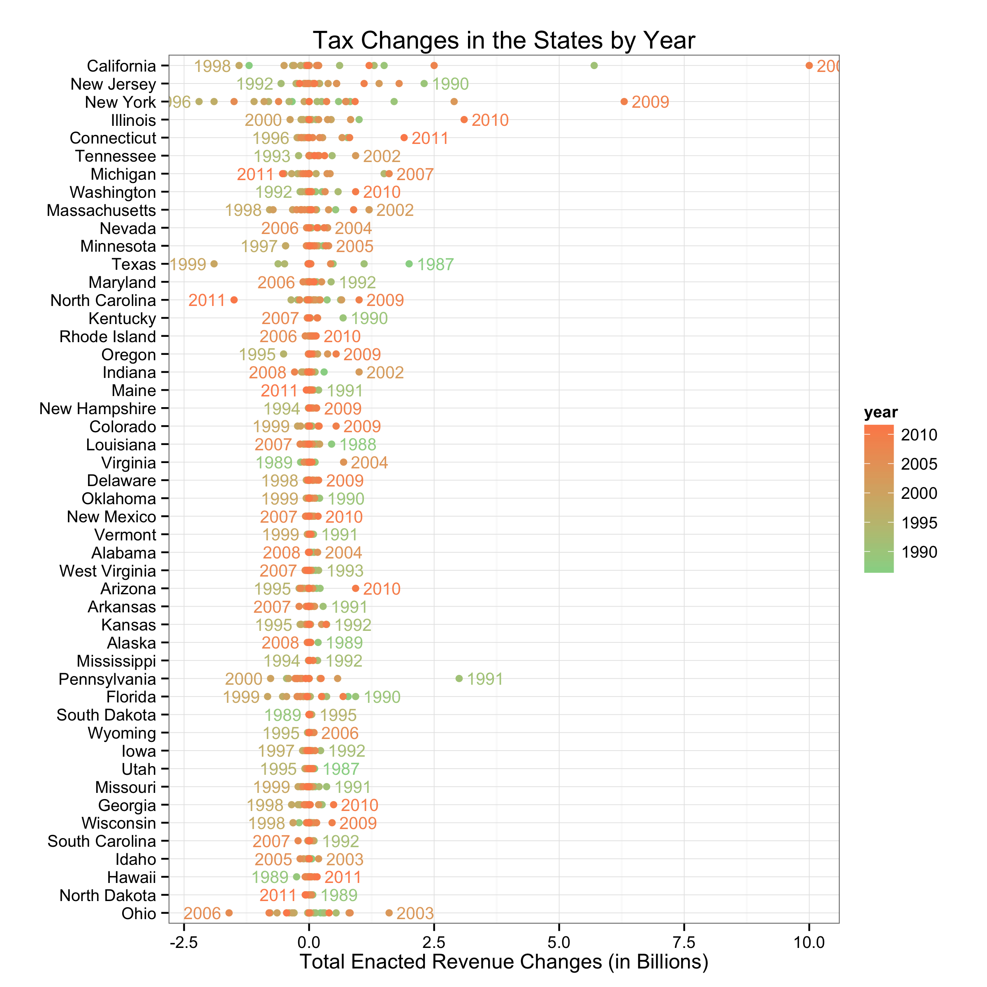

Figure 1: This figure plots the total enacted revenue changes in each state-year from 1987 to 2011. The year of the smallest and largest tax change is labeled on the plot.

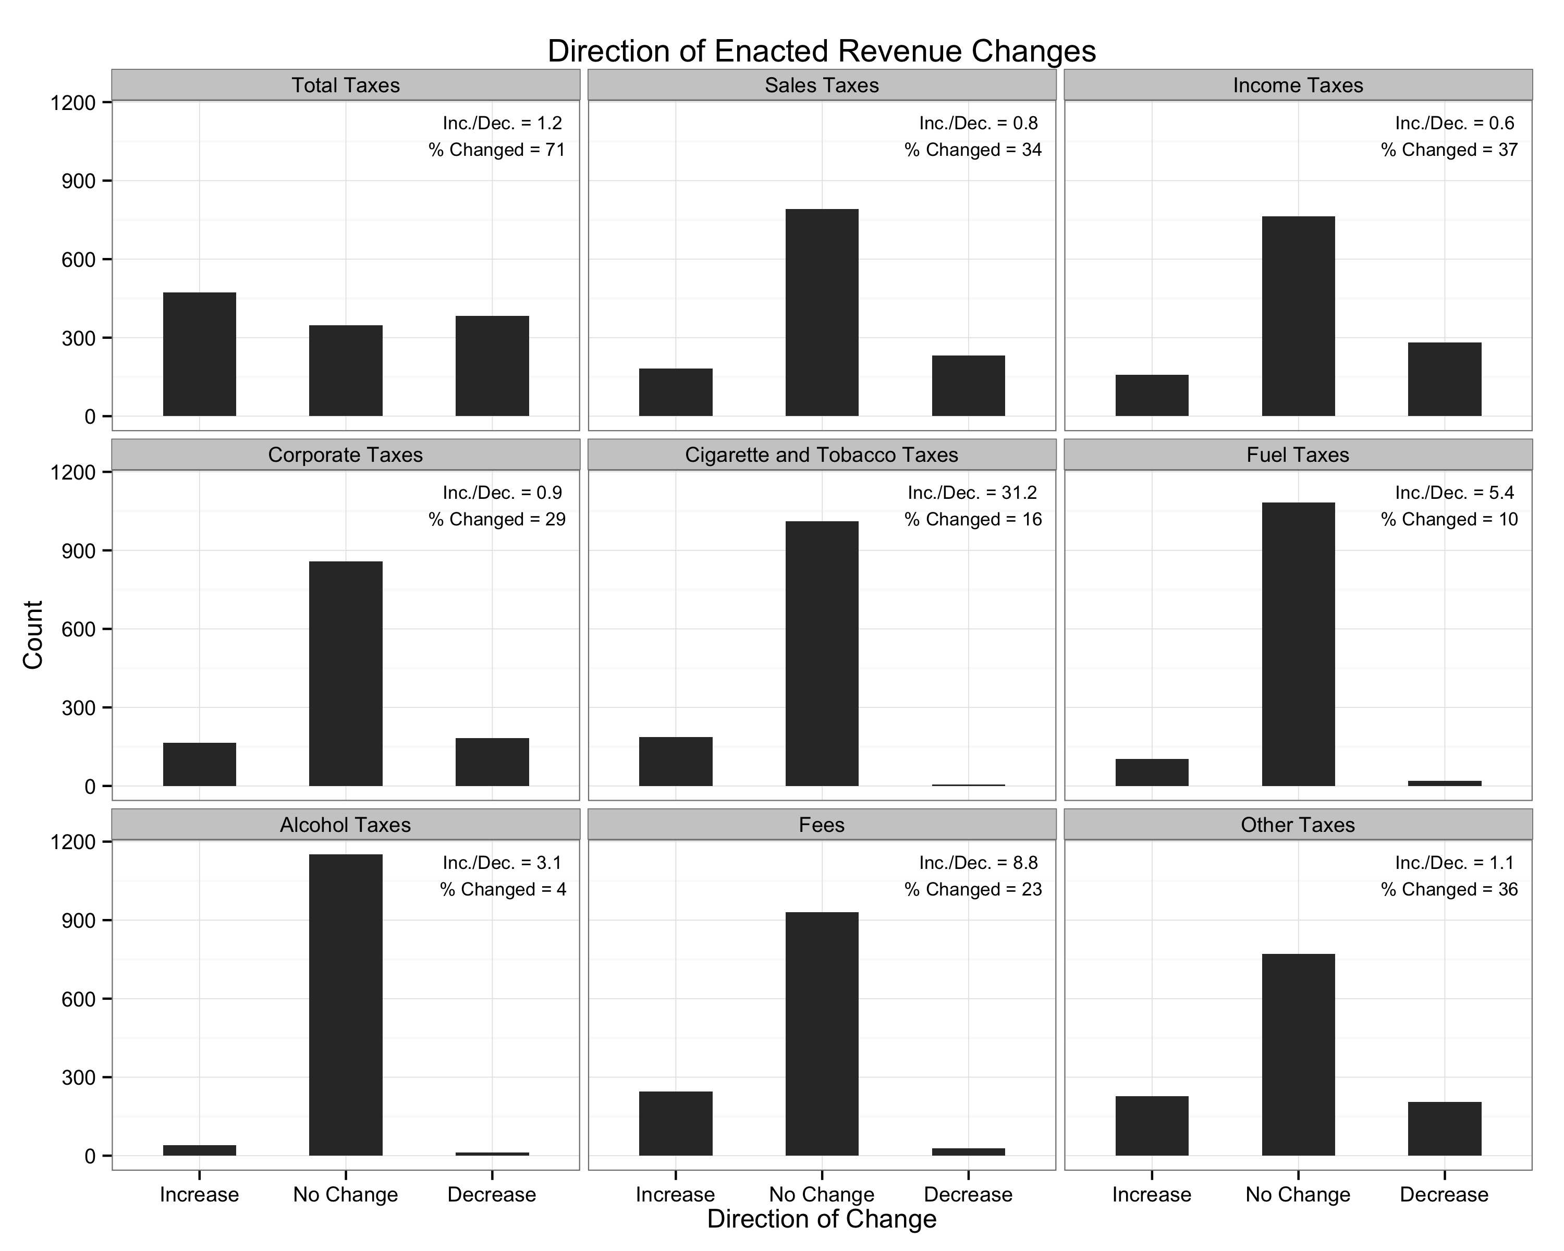

Figure 2: This figure shows the distribution of the direction of enacted revenue changes across the eight tax categories and the total taxes.

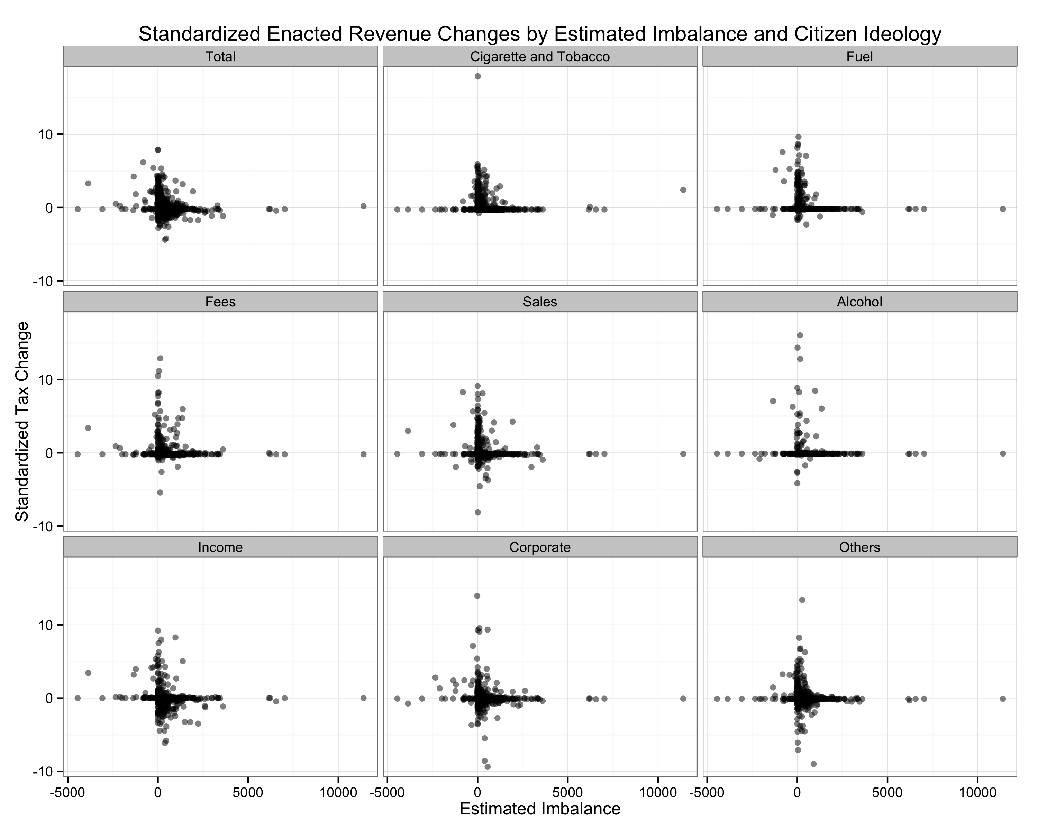

Figure 3: This figure shows the relationship between the estimated imbalance and the standardize tax change. To aid interpretation, we standardize enacted revenue changes to have a mean of zero and standard deviation of one. Notice the unusual distribution of the outcome variable—many zeros and many highly unusual changes (e.g., 10 standard deviations or more)

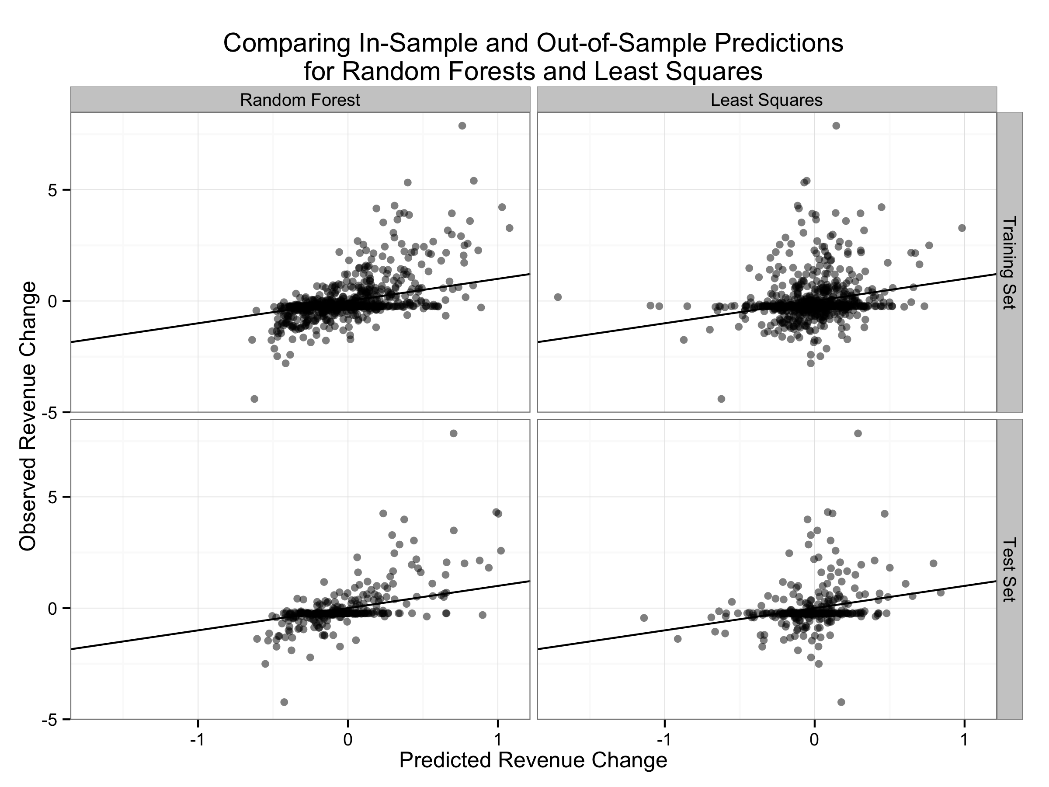

Figure 4: This figure compares the observed revenue changes to the predictions from a Random Forest and least squares regression. The top row shows the predictions for the training set (i.e., in-sample prediction) and the bottom row shows the predictions for the test set (i.e., out-of-sample prediction). Notice that the predictions from the Random Forests follow the actual values noticeably better than the least squares estimates.

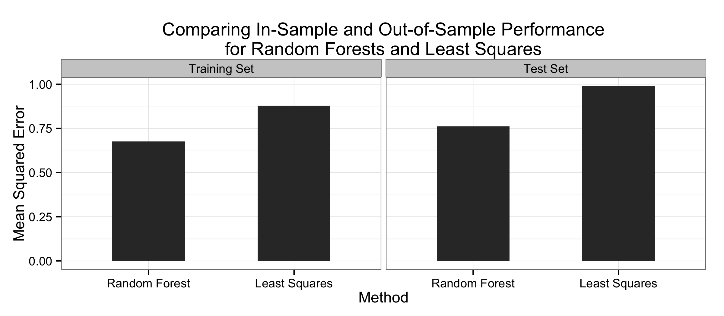

Figure 5: This figure present the mean squared error for the predictions in both the training and test sets for both a Random Forest and least squares. Notice that the Random Forest produce considerably smaller errors than least squares in both the training and test sets. Most importantly, the Random Forest performs better in the test set than least squares performs in the training set.

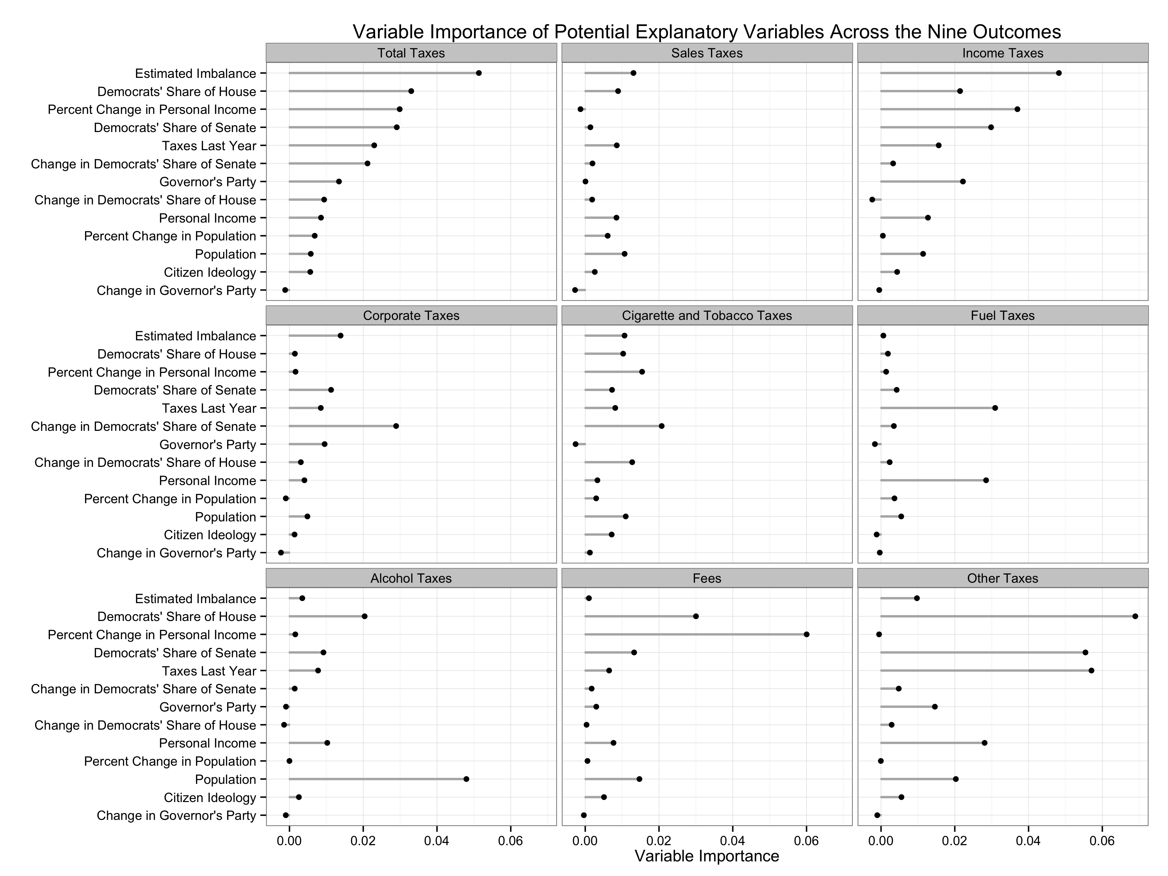

Figure 6: This figure shows the variable importance for each explanatory variable and each tax class. We standardized the outcome variables to have standard deviation equal to one prior to the analysis.

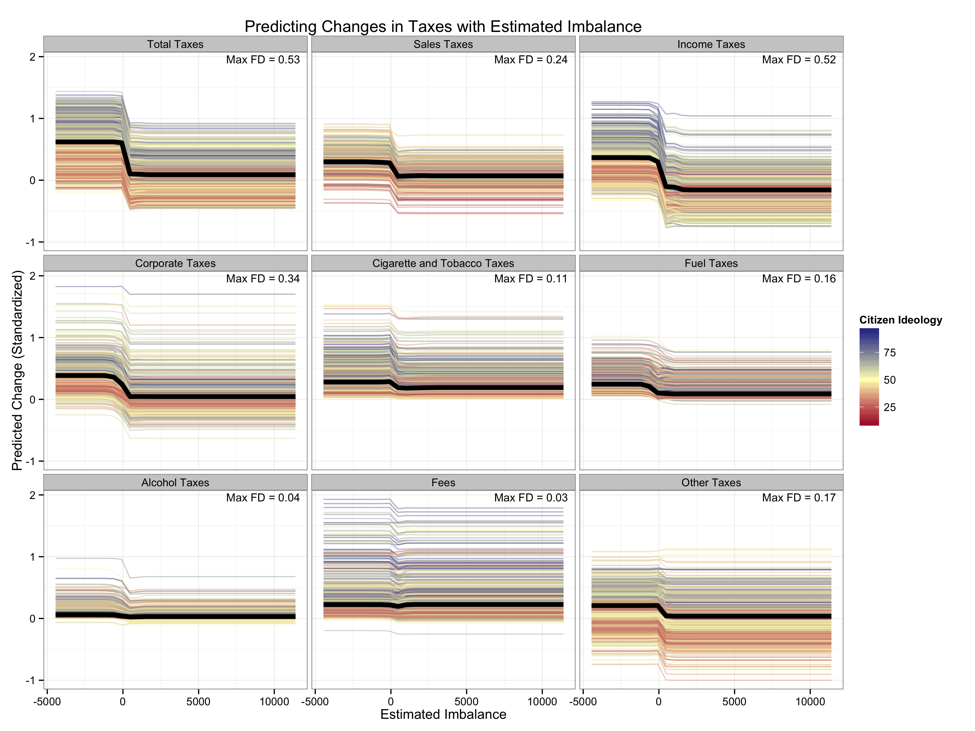

Figure 7: This figure shows the predicted tax change for each tax class as the estimated imbalance varies. Each colored line corresponds to a particular state-year. We fix the other explanatory variables to the values observed for that particular state-year and allow the estimated imbalance to vary from a high value to a low value. We repeat this for each state-year. The lines are colored by the ideology of the state’s citizens. The heavy black line shows the mean prediction at each value of estimated imbalance. The first differences reported in the upper-right corner report the difference between the maximum average prediction and the minimum average prediction.

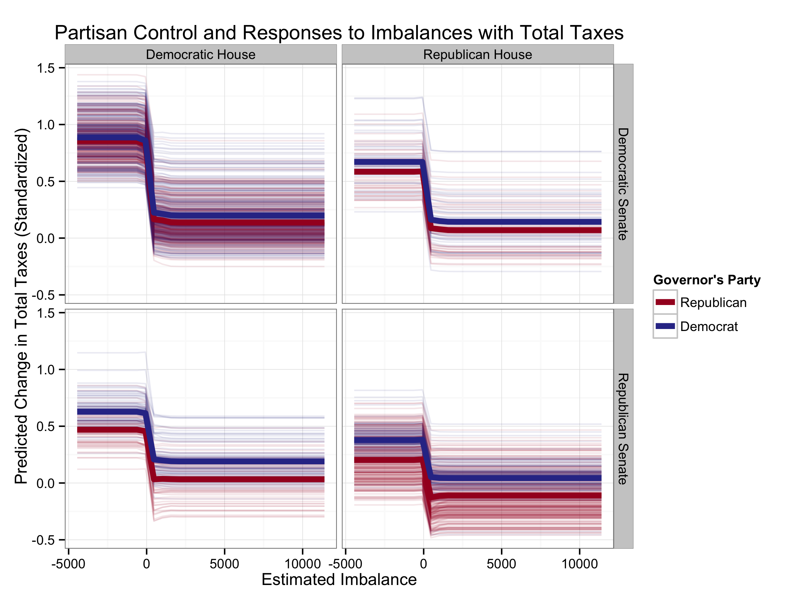

Figure 8: This figure shows the predicted tax change for total taxes as the estimated imbalance varies by party control of the house, senate, and governor. Each light line corresponds to a particular state-year. We fix the other explanatory variables to the values observed for that particular state-year and allow the estimated imbalance to vary from a high value to a low value. We repeat this for each state-year. The left-hand column contains those observations with a Democrat-controlled house and the right-hand column contains those observations with a Republican-controlled house. The top-row contains those observations with a Democrat-controlled senate and the bottom-row contains those observations with a Republican-controlled senate. The heavy read and blue lines indicate the average across the predictions for Democratic and Republican governors, respectively.

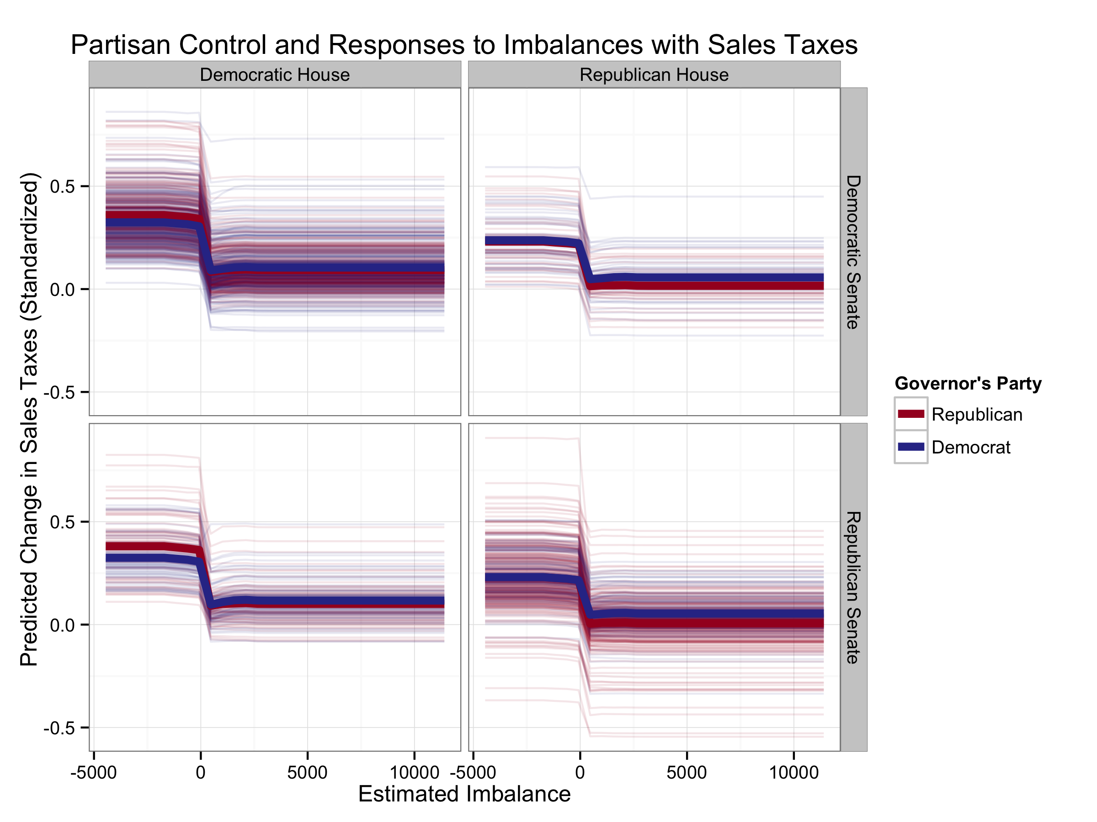

Figure 9: This figure shows the predicted tax change for sales taxes as the estimated imbalance varies by party control of the house, senate, and governor. Each light line corresponds to a particular state-year. We fix the other explanatory variables to the values observed for that particular state-year and allow the estimated imbalance to vary from a high value to a low value. We repeat this for each state-year. The left-hand column contains those observations with a Democrat-controlled house and the right-hand column contains those observations with a Republican-controlled house. The top-row contains those observations with a Democrat-controlled senate and the bottom-row contains those observations with a Republican-controlled senate. The heavy read and blue lines indicate the average across the predictions for Democratic and Republican governors, respectively.

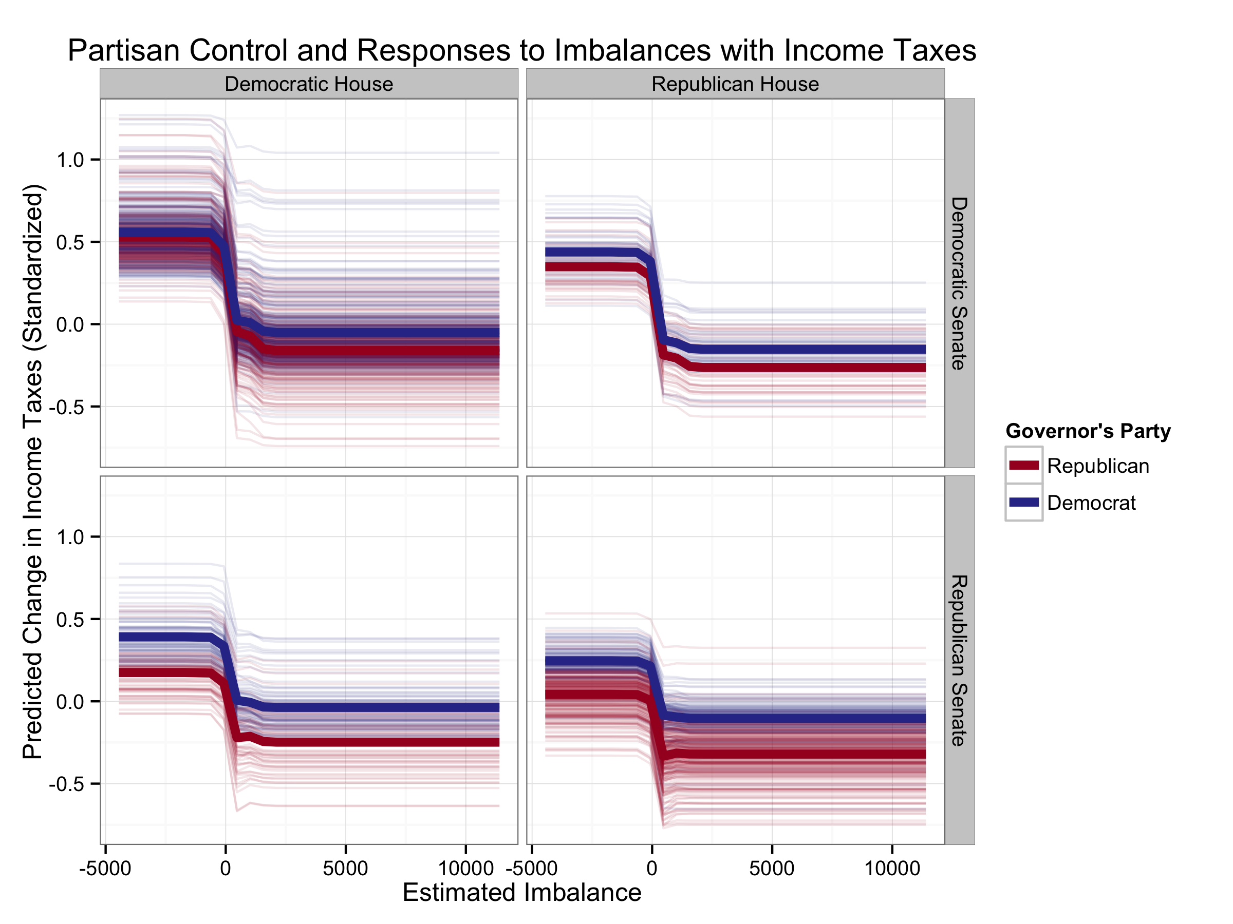

Figure 10: This figure shows the predicted tax change for income taxes as the estimated imbalance varies by party control of the house, senate, and governor. Each light line corresponds to a particular state-year. We fix the other explanatory variables to the values observed for that particular state-year and allow the estimated imbalance to vary from a high value to a low value. We repeat this for each state-year. The left-hand column contains those observations with a Democrat-controlled house and the right-hand column contains those observations with a Republican-controlled house. The top-row contains those observations with a Democrat-controlled senate and the bottom-row contains those observations with a Republican-controlled senate. The heavy read and blue lines indicate the average across the predictions for Democratic and Republican governors, respectively.

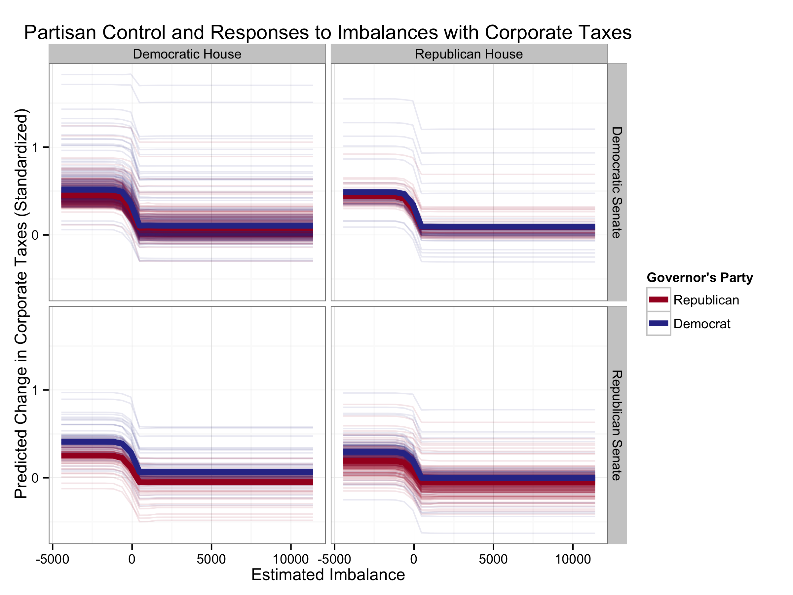

Figure 11: This figure shows the predicted tax change for corporate taxes as the estimated imbalance varies by party control of the house, senate, and governor. Each light line corresponds to a particular state-year. We fix the other explanatory variables to the values observed for that particular state-year and allow the estimated imbalance to vary from a high value to a low value. We repeat this for each state-year. The left-hand column contains those observations with a Democrat-controlled house and the right-hand column contains those observations with a Republican-controlled house. The top-row contains those observations with a Democrat-controlled senate and the bottom-row contains those observations with a Republican-controlled senate. The heavy read and blue lines indicate the average across the predictions for Democratic and Republican governors, respectively.

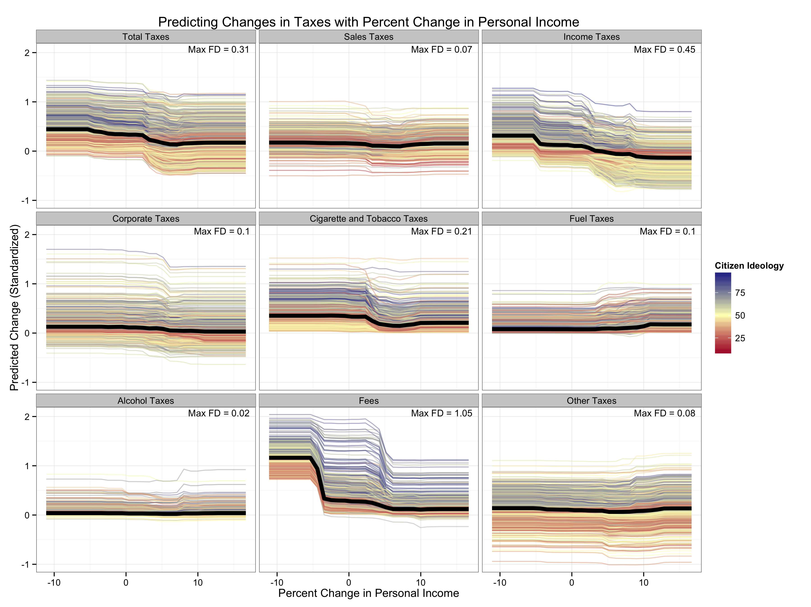

Figure 12: This figure shows the predicted tax change for each tax class as the percentage change in personal income varies. Each colored line corresponds to a particular state-year. We fix the other explanatory variables to the values observed for that particular state-year and allow the percentage change in personal income to vary from a high value to a low value. We repeat this for each state-year. The lines are colored by the ideology of the state’s citizens. The heavy black line shows the mean prediction at each value of estimated imbalance. The first differences reported in the upper-right corner report the difference between the maximum average prediction and the minimum average prediction.

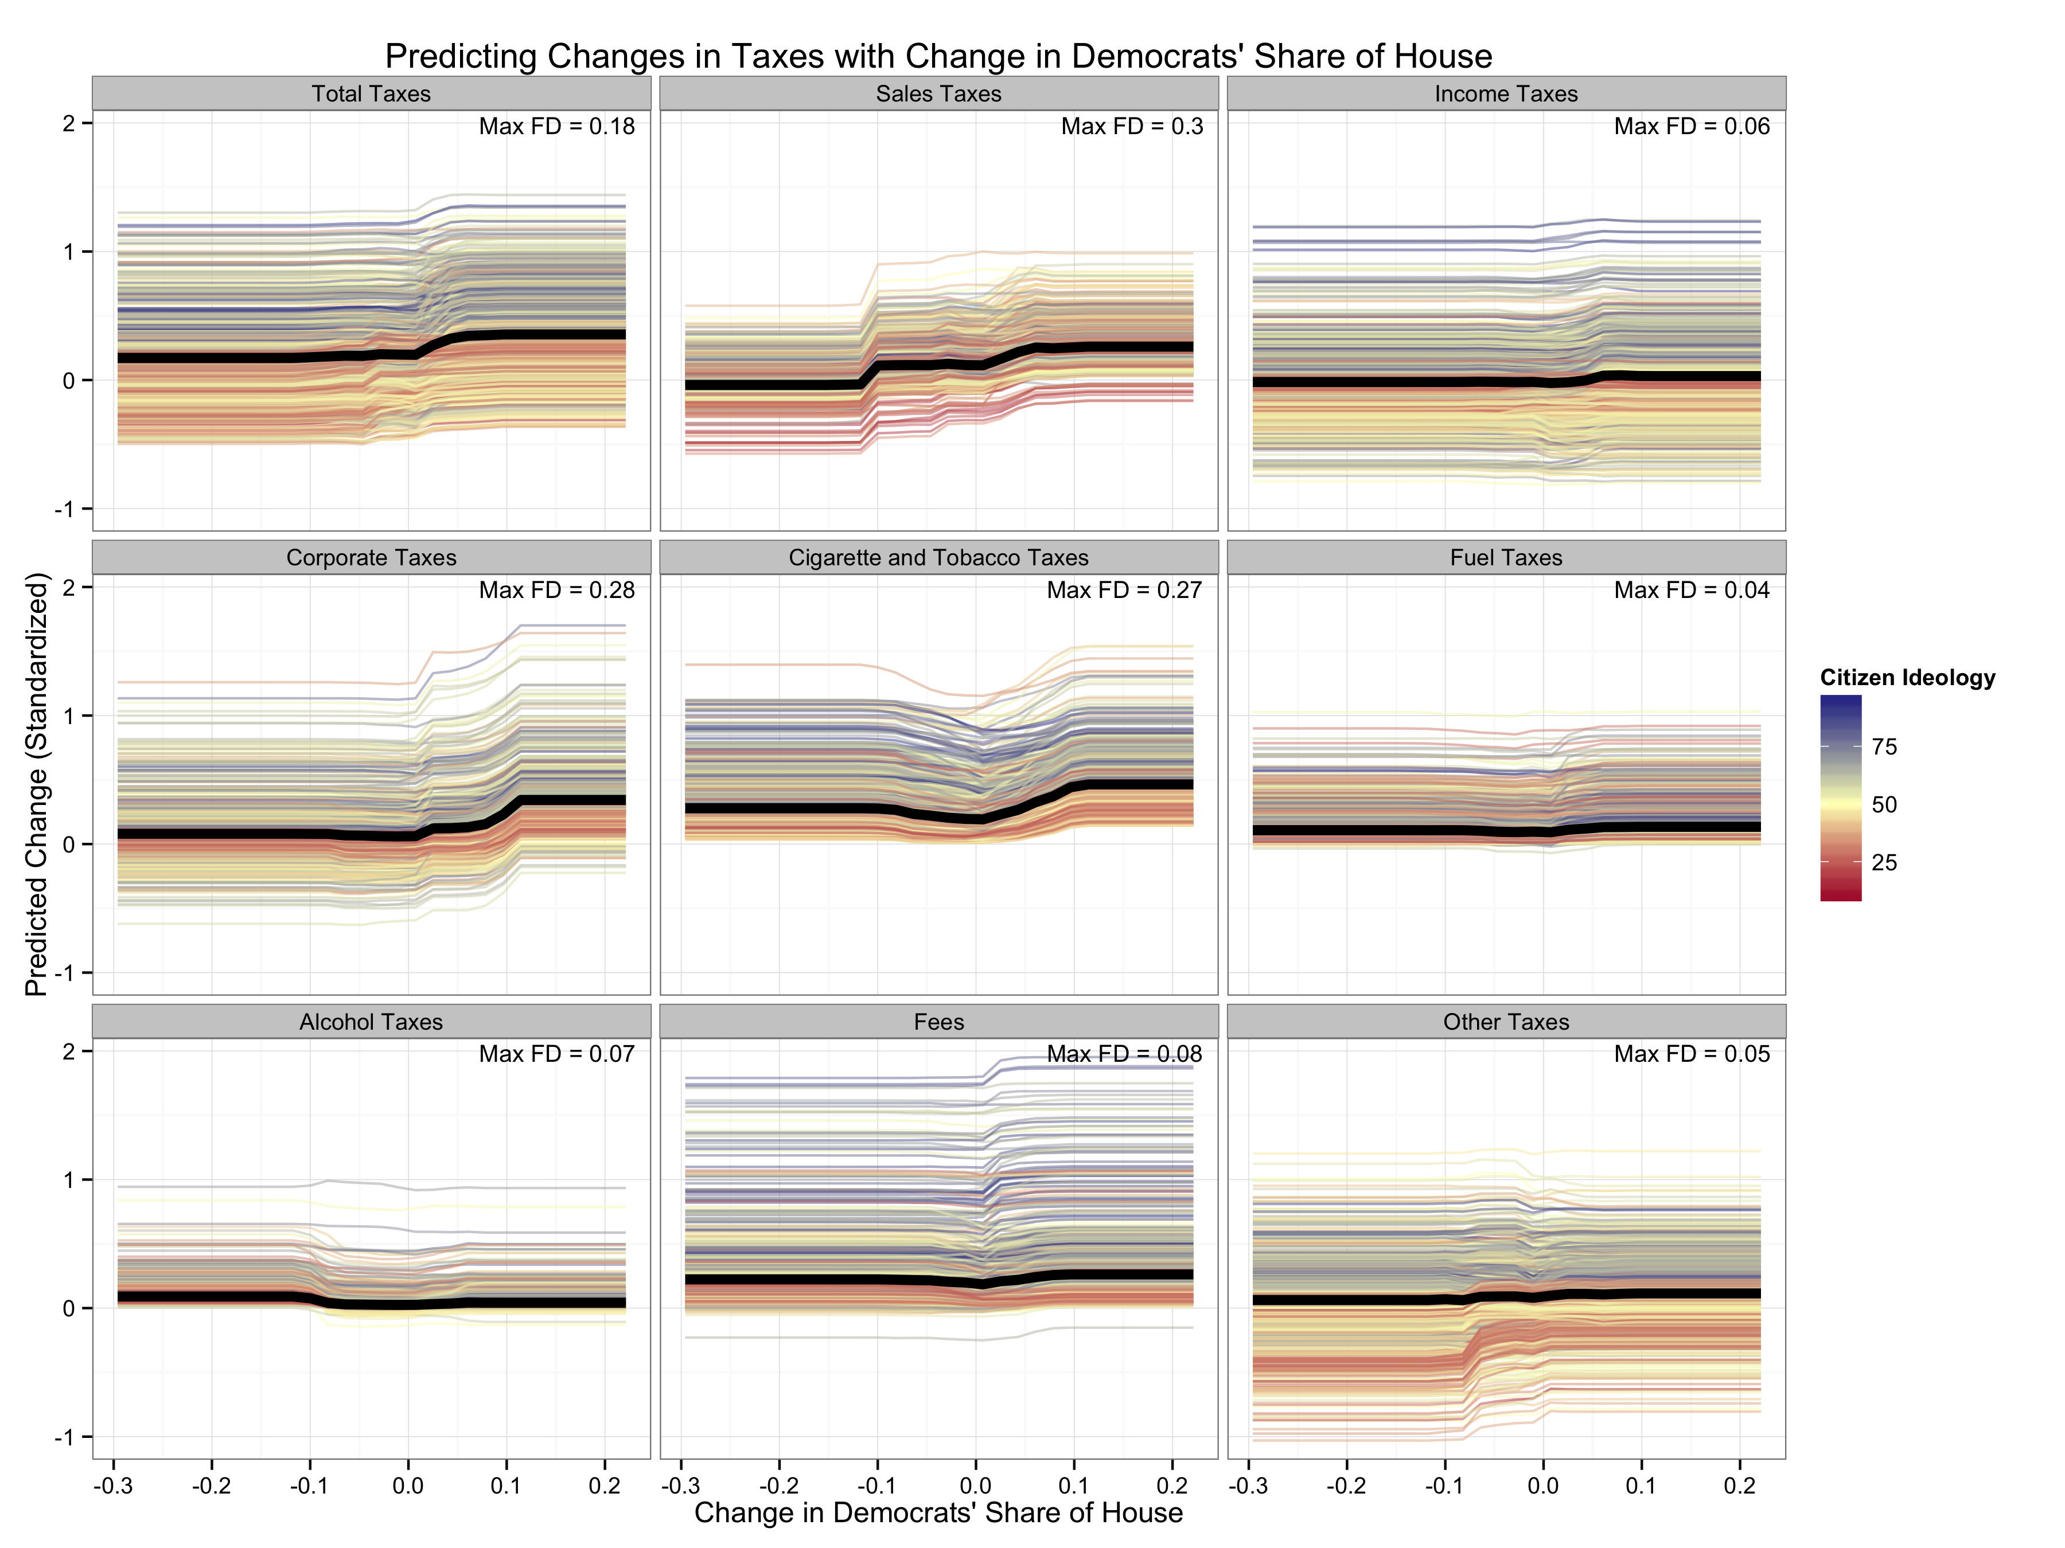

Figure 13: This figure shows the predicted tax change for each tax class as the change in Democrats’ share of the state house varies. Each colored line corresponds to a particular state-year. We fix the other explanatory variables to the values observed for that particular state-year and allow the change in Democrats’ share of the state house to vary from a high value to a low value. We repeat this for each state-year. The lines are colored by the ideology of the state’s citizens. The heavy black line shows the mean prediction at each value of estimated imbalance. The first differences reported in the upper-right corner report the difference between the maximum average prediction and the minimum average prediction.

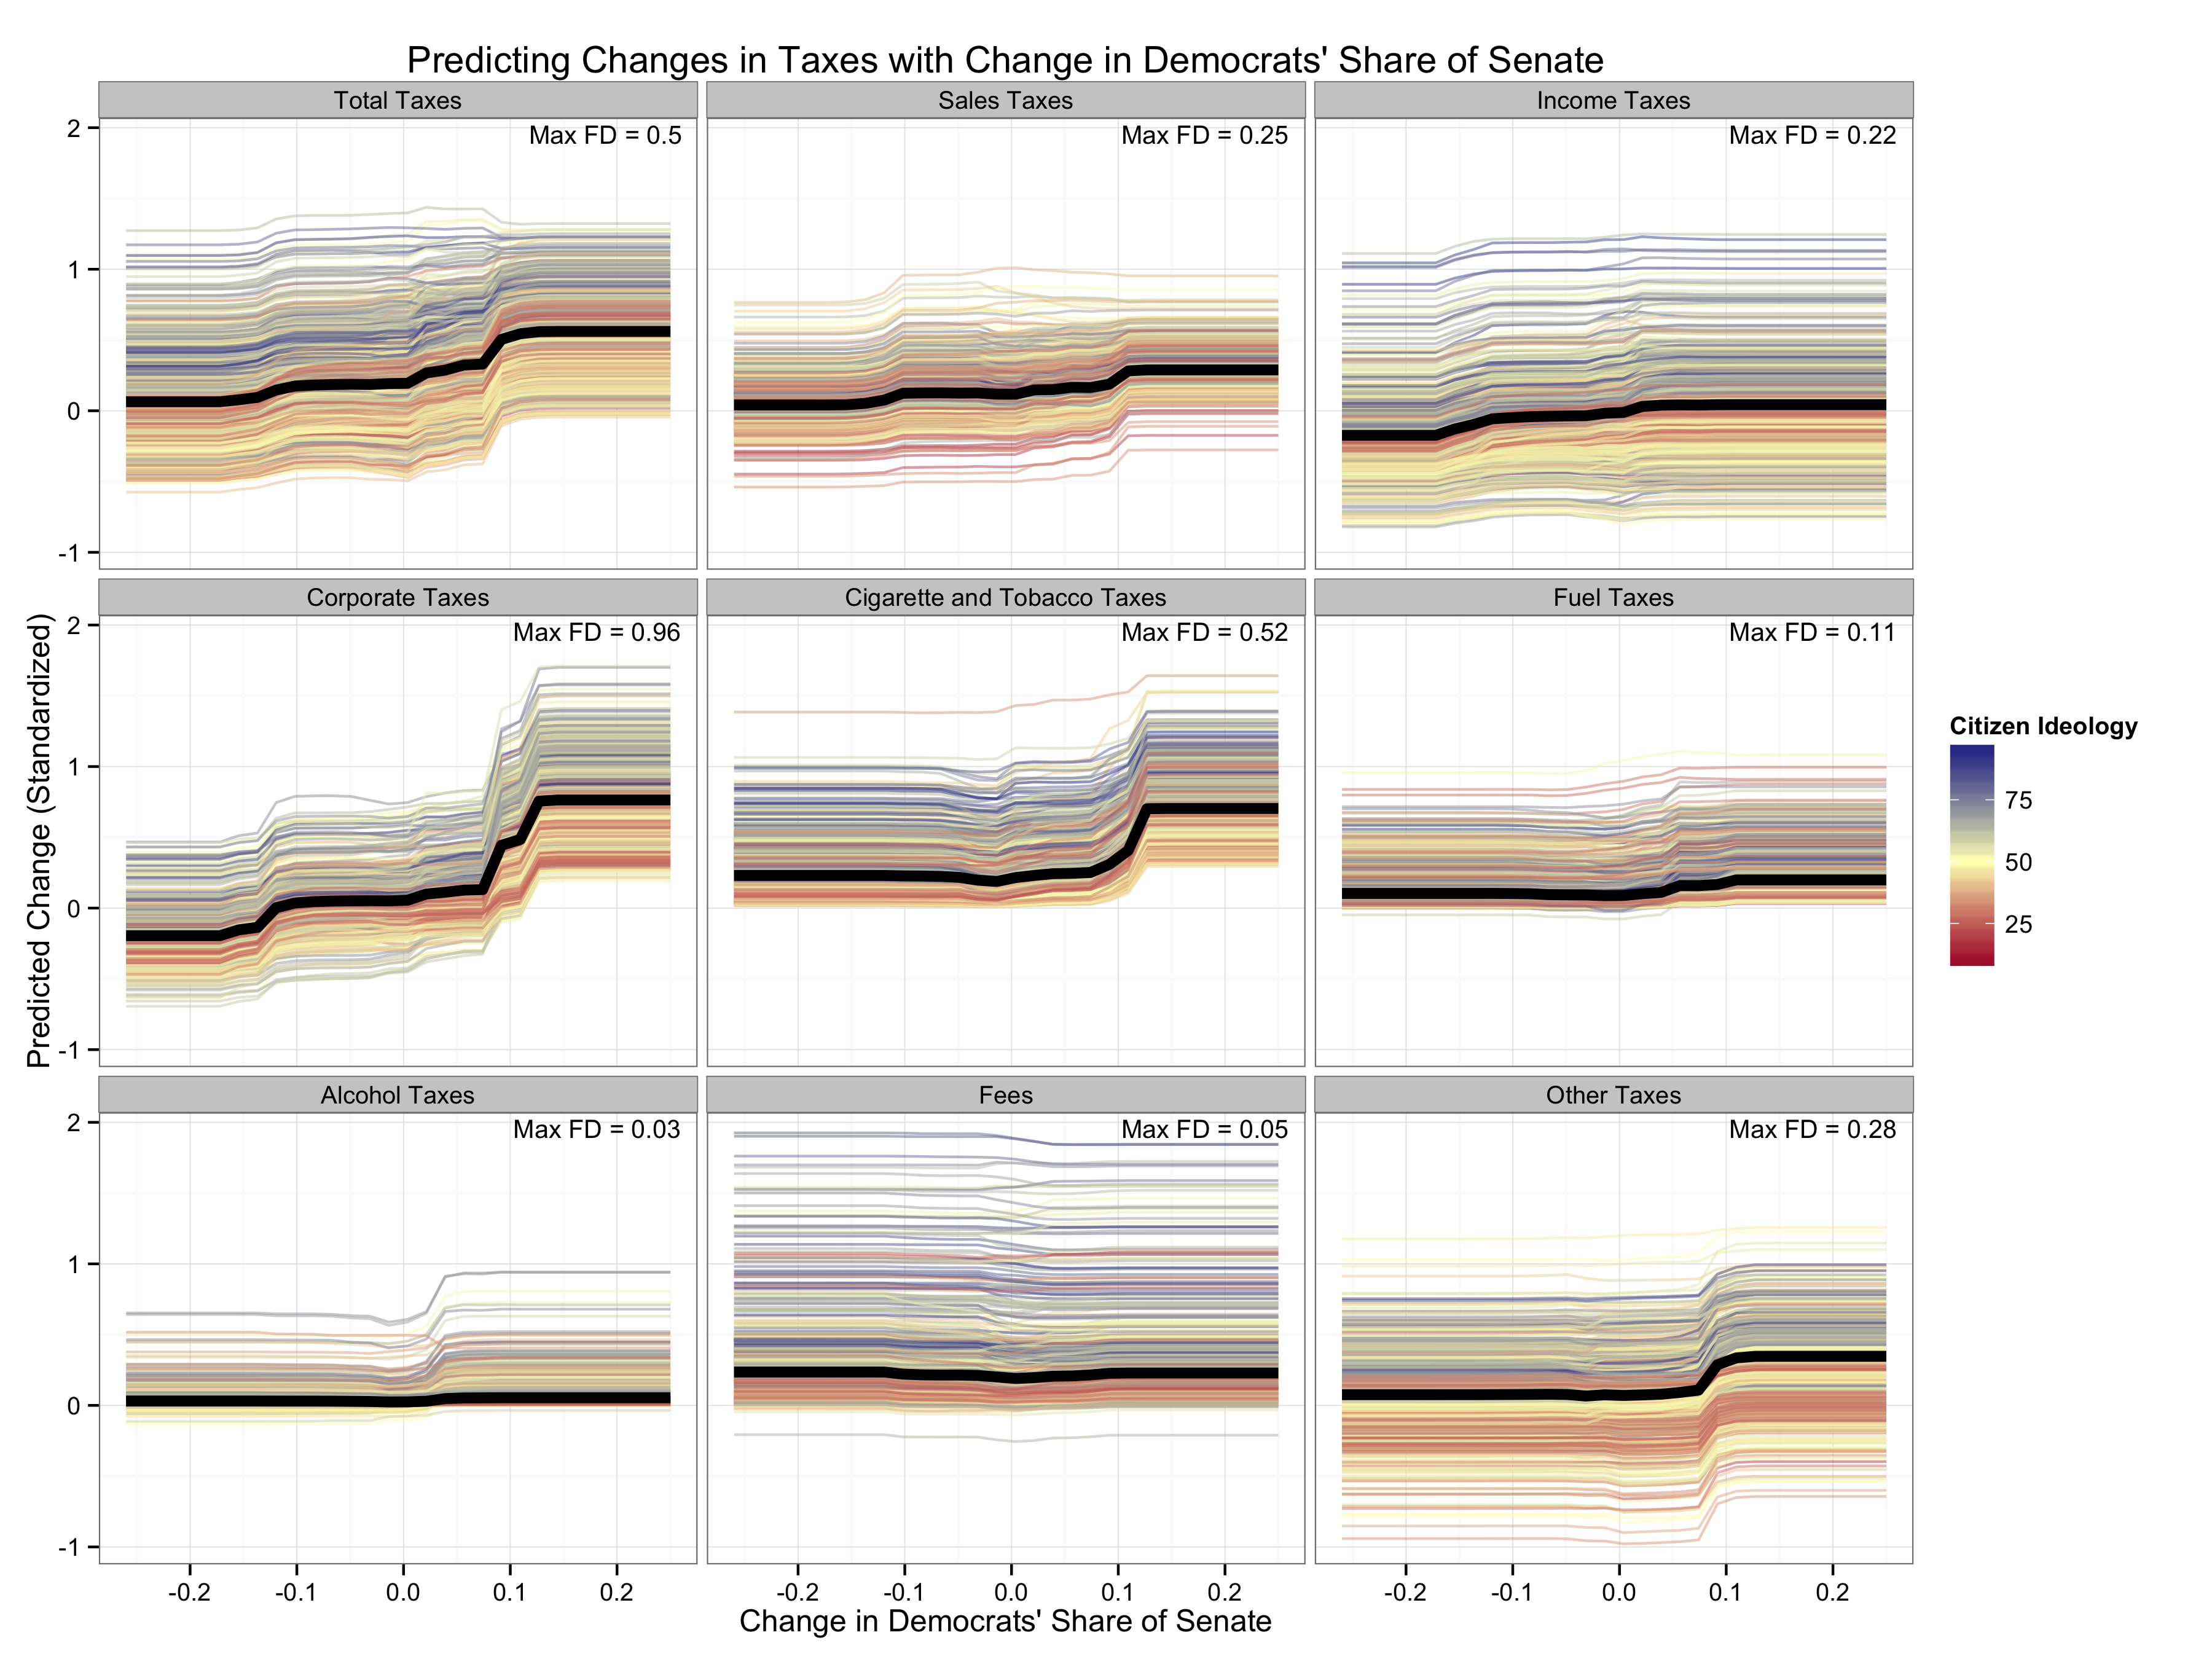

Figure 14: This figure shows the predicted tax change for each tax class as the change in Democrats’ share of the state senate varies. Each colored line corresponds to a particular state-year. We fix the other explanatory variables to the values observed for that particular state-year and allow the change in Democrats’ share of the state senate to vary from a high value to a low value. We repeat this for each state-year. The lines are colored by the ideology of the state’s citizens. The heavy black line shows the mean prediction at each value of estimated imbalance. The first differences reported in the upper-right corner report the difference between the maximum average prediction and the minimum average prediction.

1. * All data and code to replicate these results are available at <https://github.com/carlislerainey/asking-acting>.
2. § Carlisle Rainey is Assistant Professor of Political Science, Texas A&M University, 2010 Allen Building, College Station, TX, 77843 ([crainey@tamu.edu](mailto:crainey@tamu.edu)).
3. † Kevin Stout is a Ph.D. student in the Department of Political Science, University at Buffalo, SUNY, 520 Park Hall, Buffalo, NY, 14260 ([krstout@buffalo.edu](mailto:krstout@buffalo.edu)).
4. ‡ Richard F. Winters is the William Clinton Story Remsen Class of 1943 Professorship in Government, Emeritus, Department of Government, Dartmouth College, 211 Silsby Hall, 3 Tuck Mall, Hanover, NH, 03755 ([richard.f.winters@dartmouth.edu](mailto:richard.f.winters@dartmouth.edu)).
5. The highly-aggregated, macro-compositional approach in state policy analysis can be traced back many decades. Surely an outlier in this regard was an analysis of the determinants of the ratio between the sum of income-class-weighted classes of state expenditures over the sum of income-class-weighted tax categories, the so-called “redistribution ratio” (Fry and Winters 1972).
6. For an early and not-sufficiently-appreciated examples see Rrickson (1971).
7. Specific changes in “statutory rates of sales and/or income taxation” is an ever-declining fraction of all changes in these two taxes in the American states, see Rainey Stout, and Winters (2016).
8. For a test of this hypothesis, see Rainey, Stout, and Winters (2016).
9. This seems to contradict Beamer's (1999) interesting observation that state legislators appear to believe that voters more strongly favor sales taxation for financing public gods rather than income taxation. His observation squares also with Winters (1976) observations of the budget and taxing process in New Hampshire and Vermont.
10. This is largely due to the states’ actions following litigation regarding reimbursing states for the costs of health damages of cigarette smoking via the Tobacco Master Settlement Agreement.
11. For clarity, we analyze the following variable: .
12. See Montgomery and Olivella (2016) for an introduction to Random Forests directed toward political scientists.